Lithium Treatment to Disrupt Wnt Signaling
Pre-Lab Worksheet

1. What is the Wnt protein and what does it do?

2. Why is lithium chloride (LiCl) used in this lab? What affect might it have on zebrafish embryo development and in particular, Wnt signaling?

3. It will be very important to know the stages of zebrafish embryo development in this lab. Please identify the developmental stages the following embryos:

____________ ____________ ____________ ___________
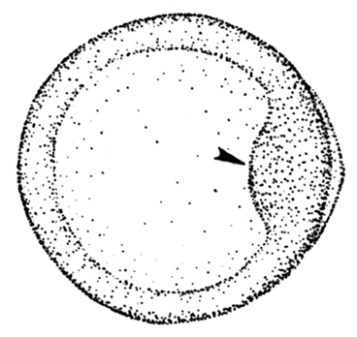

____________ ____________ ____________ ____________

4. What does it mean to dechorionate an embryo? How is dechorionation performed?

